# Preliminary Evaluation of OCR Systems for Automating Document Workflows

The goal of this study is to evaluate the feasibility of automating document workflows, specifically for bank statement processing, using state-of-the-art OCR and document understanding systems. As financial documents like bank statements often follow varied layouts and contain structured tables alongside key-value pairs, the ability to reliably extract both textual and tabular data is critical.

This evaluation focuses on these leading tools:

* **Google Document AI** – a cloud-native, pre-trained document understanding platform
* **Azure AI Document Intelligence** – Microsoft’s intelligent document processing service
* **Mistral OCR** – a lightweight OCR system that preserves document layout in markdown format
* **AWS Textract –** Amazon’s OCR service that supports key-value pair and table extraction, with integration into AWS workflows.
* **Other Potential systems include Hyper Science which cannot be tested as no free or testing API.**

Each tool was tested on a variety of real-world bank statement samples to assess their accuracy, structural understanding, and the post-processing effort required to convert raw outputs into structured, actionable data.

## 1. Target fields that need to be Extracted and Updated

* **Case Information (mostly will come with system)**
  1. Case (Number) – INT
  2. Status – Drop Down
  3. Mode – DropDown
  4. Do: DropDown
  5. Worker -??
  6. Rede -??
* **Individual Information:**
  1. Name – Name of the account holder
* **Transaction Details:**

1. Institution name (bank or other institution where transaction happened) – Str
2. Transaction type (credit or debit?) or (bank transfer, pos machine etc?) – Drop down - classification
3. Institution number – (Account number?) - Int
4. Check – (Check number if it is check transaction?) – Int – (Optional)
5. Account type (savings or checking or asset transfer?) – Drop Down - Classification
6. Transaction date – Date on which transaction happened? – datetime format

* **Transaction information:**
  1. Resource Type -??
  2. Transferred to – Where the resource has been transferred
  3. Relation – how to received person related to client?
* **Additional Transactional Information:** 
  1. Transaction Value: value of transaction – Int
  2. Amount transferred – is it same as transaction value?
  3. Verification -??
  4. Comments -??
  5. Status – Cleared or Not Cleared?

## 2. Comparison of results for different bank statement

### 1. Key bank (Low dpi statement)

Google Doc AI

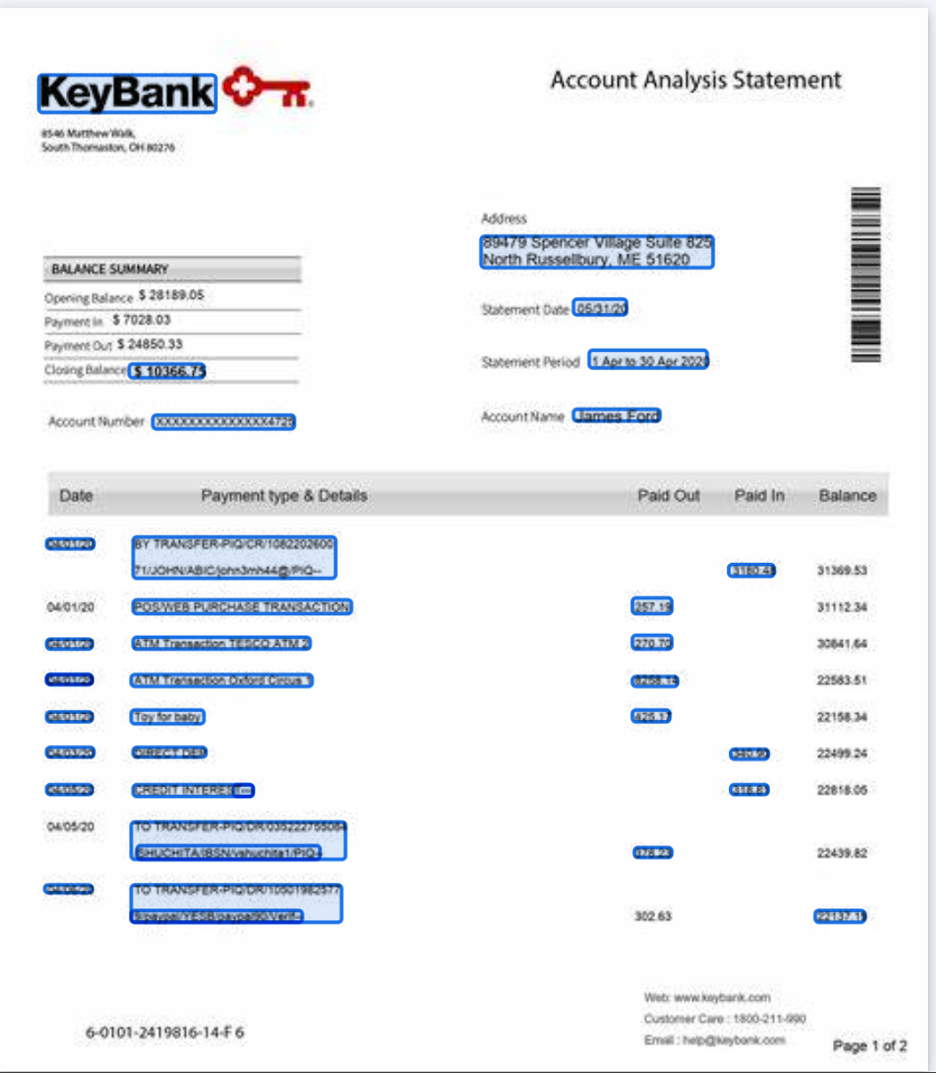

Azure AI

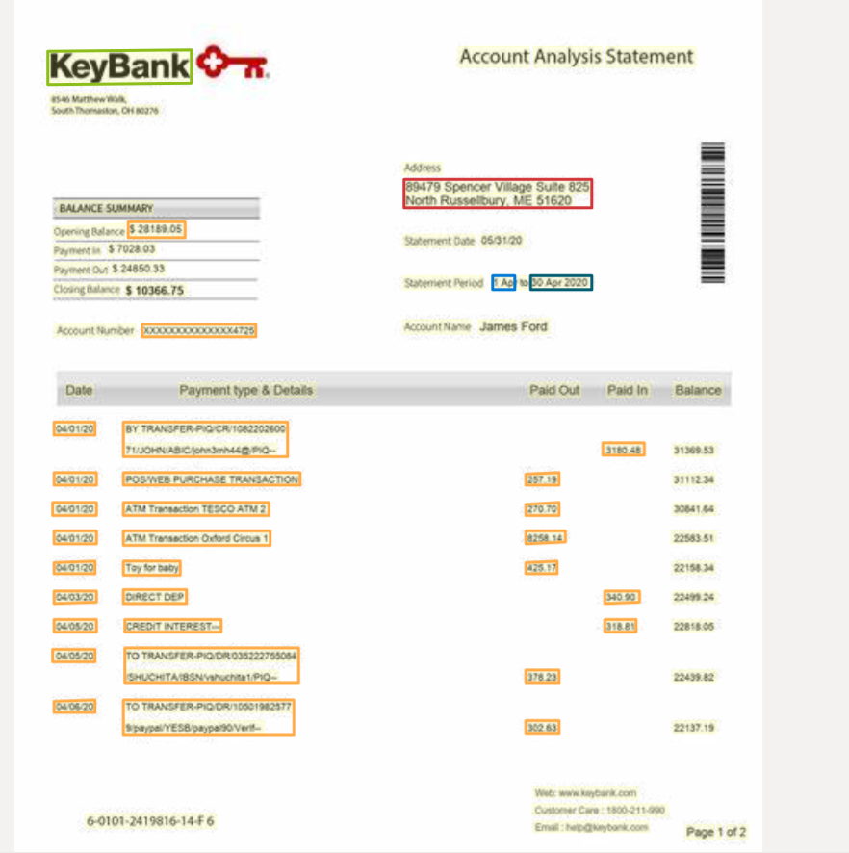

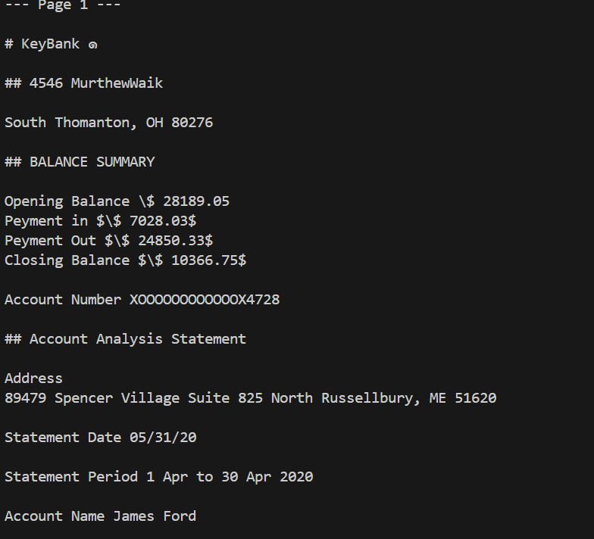

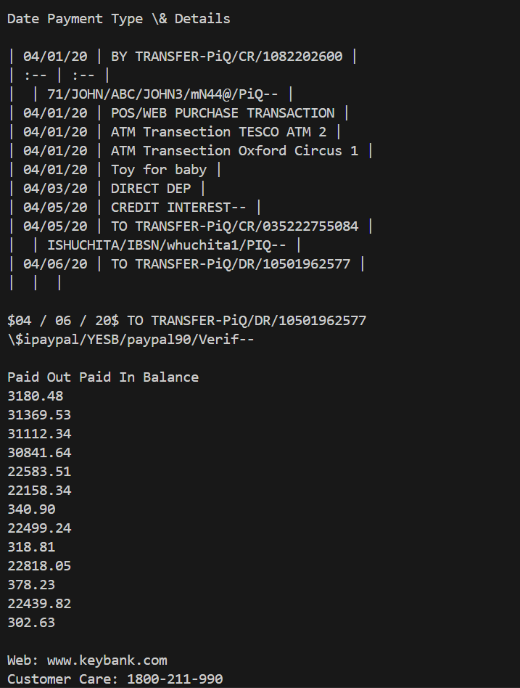

Result comment

* Google Doc AI
  1. In transaction couple of dates have not been identified.
  2. Taken Statement end data as entire statement period
  3. Taken statement start date as data of first transaction
  4. Did not pick last paid out transaction and wrongly identified balance as last date.
* Azure AI
  1. Only relevant field is it has not picked names
* Mistral OCR
  1. It has picked entire text but did not structure it in this place so not usable

### 2. High DPI Statement

Google DOC AI

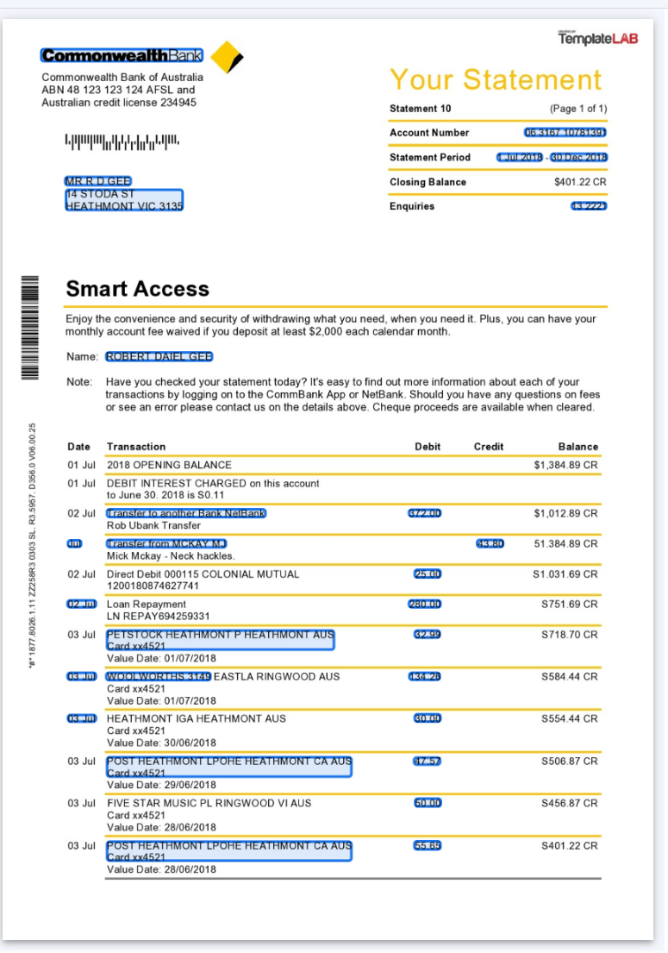

Azure AI

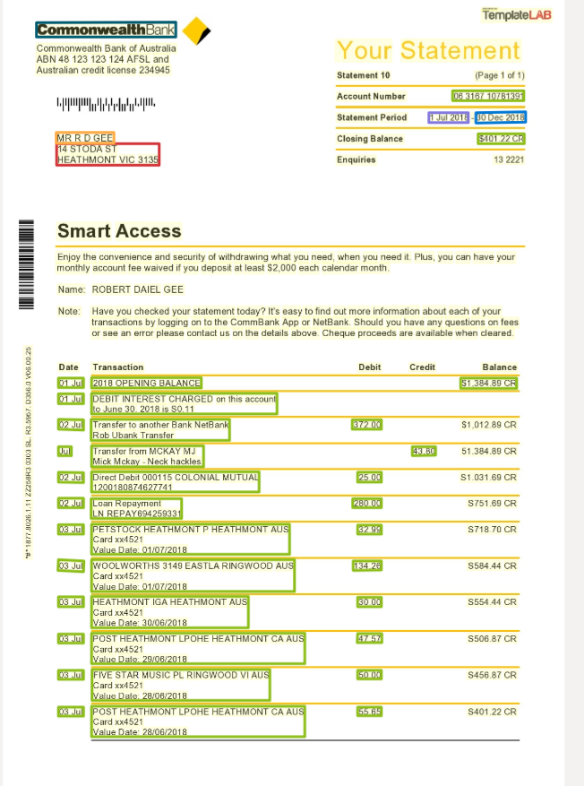

Mistral OCR

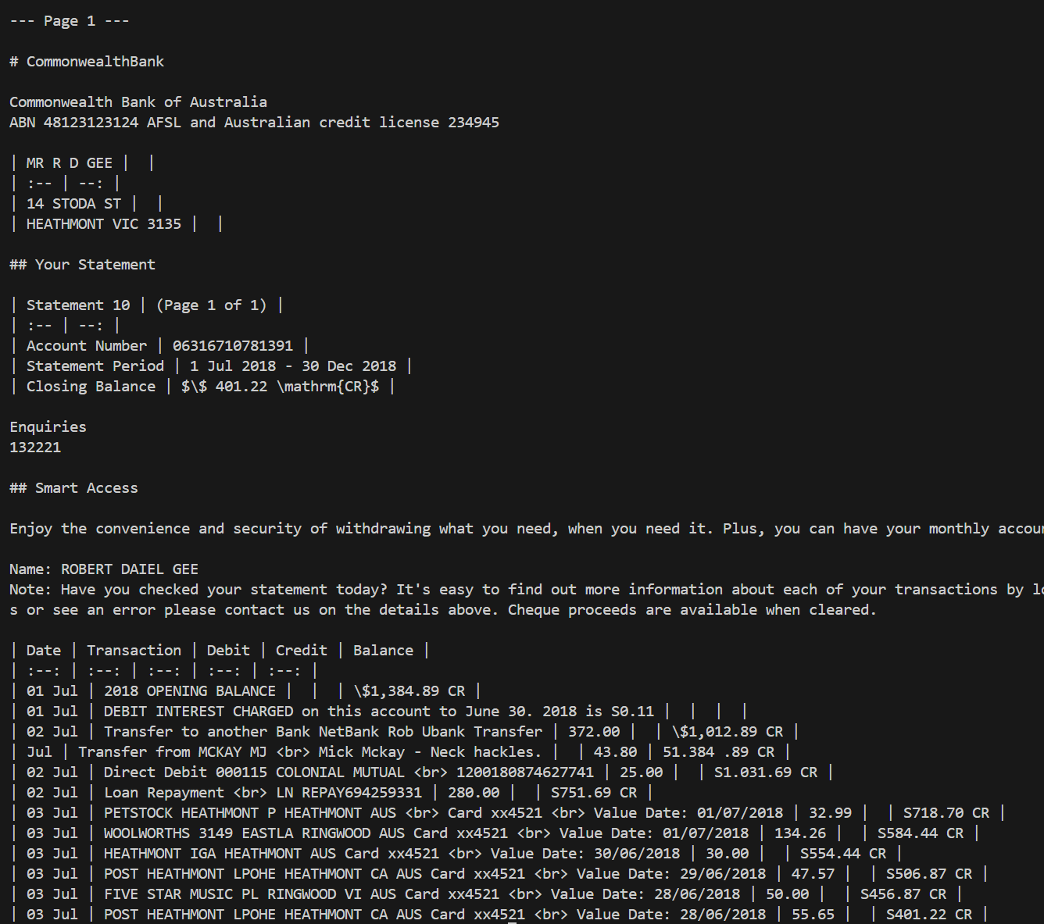

Comparison Comments

**Google DOC AI:**

* Missed lot of dates, transactions and lot of non-years dates are also not labelled properly.

**Azure AI**

* Picked all the transactions properly including, names, account number, data labeling and transaction labeling.

**Mistral OCR**

* Picked all the data even table is correctly formatted with border lines for parsing.
* But again need different trained model for post processing.

### 3. Bank direct pdf

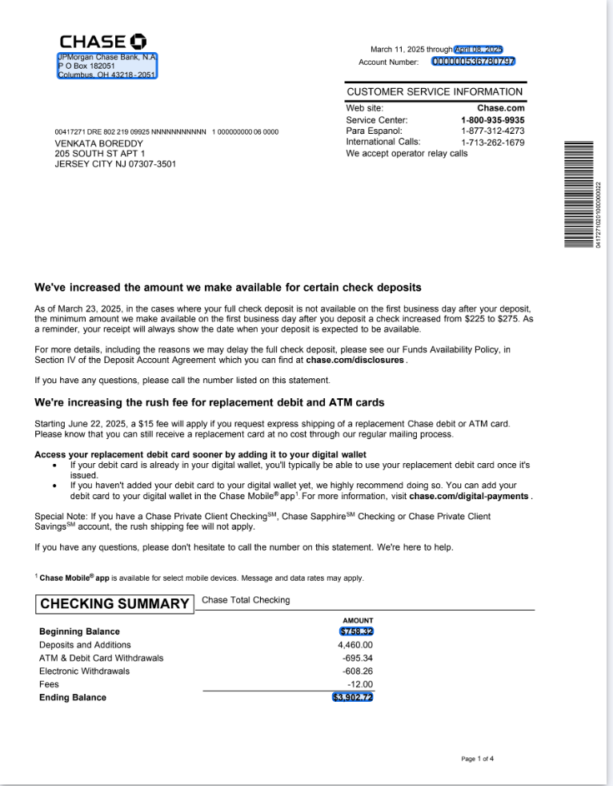

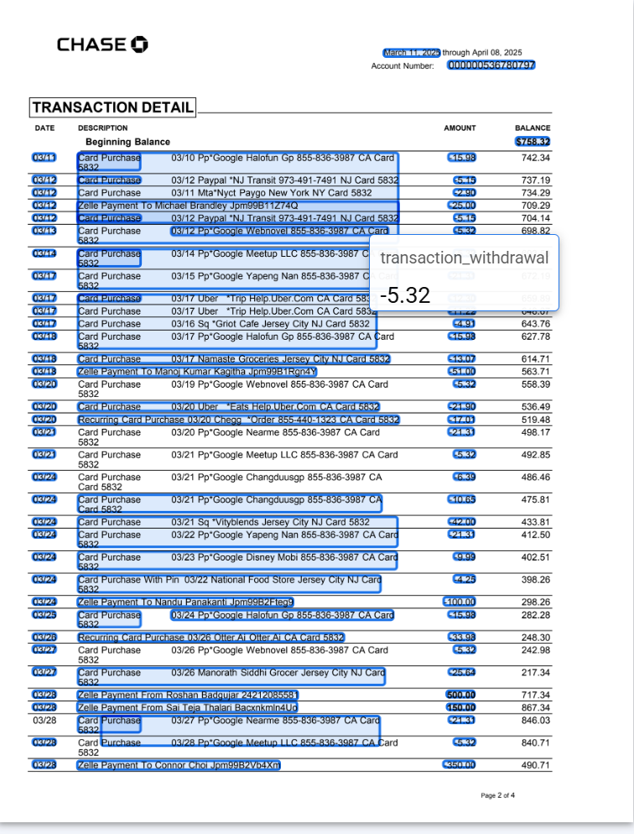

Azure AI

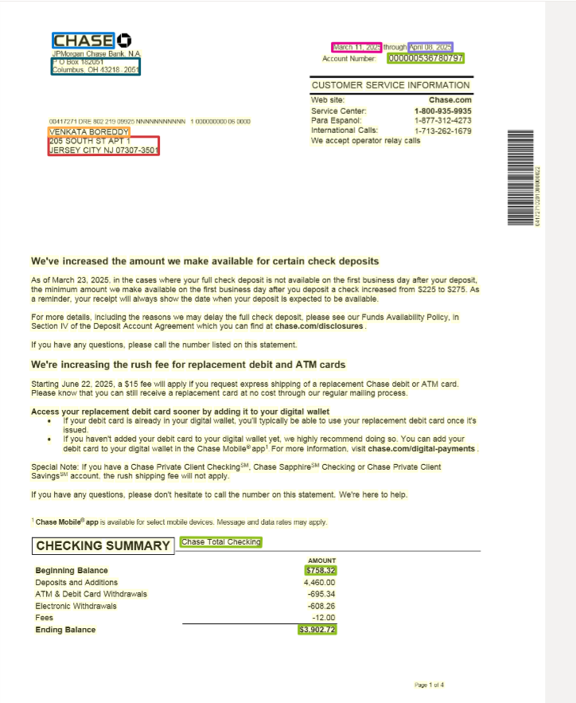

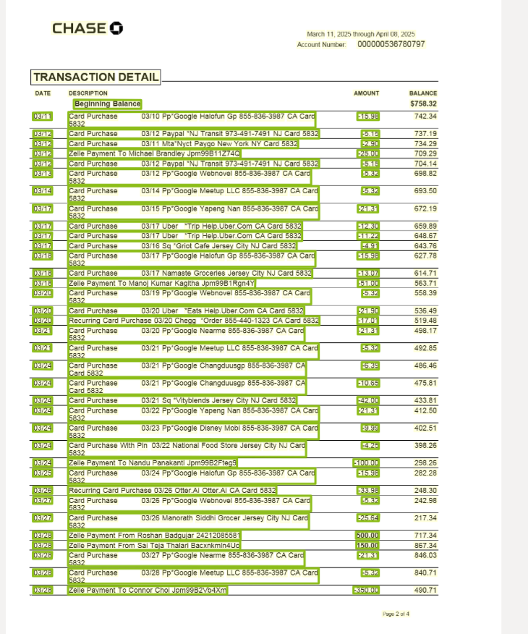

Mistral OCR

